

American International University-Bangladesh (AIUB)

**Department of Computer Science Faculty of Science & Technology (FST)**

**Smart Hotel Management System** A Software Requirement Engineering Project Submitted

By

|  |  |  |  |  |
| --- | --- | --- | --- | --- |
| **Semester: Spring_22_23** | | **Section: E** | **Group Number:** | |
| SN | Student Name | Student ID | Contribution in %  (CO+CO2) | Individual  Marks |
| 1 | MINHAZ AHMED AYON | 20-41859-1 | 25% |  |
| 2 | MD. SAJIDUL HAQUE SHOHAN | 20-42022-1 | 25% |  |
| 3 | MEHENAZ TABASSOOM | 19-41398-3 | 25% |  |
| 4 | SHOWRAV KARMAKAR | 20-42927-1 | 25% |  |

The project will be evaluated for the following Course Outcomes

|  |  |  |
| --- | --- | --- |
| Evaluation Criteria | Total Marks (50) | |
|  | |
| Introduction, Format, Submission, Defense | [10 Marks] |  |
| System Overall Description & Functional Requirements | [10 Marks] |  |
| System Quality Attributes and Project Requirements | [10 Marks] |  |
| UML and E-R Diagram with Data Dictionary | [10 Marks] |  |
| UI/UX Prototyping | [10 Marks] |  |

Software Requirements

Specification

**for**

**Smart Hotel Management System**

### Version 1.0 approved

**Prepared by**

**MINHAZ AHMED AYON**

**MD. SAJIDUL HAQUE SHOHAN**

**MEHNAZ TABASSOOM**

**SHOWRAV KARMAKAR**

**Group-……**

**DATE CREATED - ………….**

Table of Contents

Version 1.0 approved 2

Revision History 3

1. Introduction 4

1.1 Purpose 4

1.2 Document Conventions 4

1.3 Intended Audience and Reading Suggestions 4

1.4 Product Scope 4

2. Overall Description 5

2.1 Product Perspective 5

2.2 Product Functions 5

2.3 User Classes and Characteristics 5

2.4 Operating Environment 6

2.5 Design and Implementation Constraints 6

2.6 Assumptions and Dependencies 7

3. System Requirements 7

3.1 System Features 7

3.1.1 Functional Requirements of customers 7

3.1.2 Functional Requirements of Management 8

3.1.3 Functional Requirements of Receptionist 9

3.2 Non-Functional/Quality Requirements 9

3.3 Project Requirements 11

4.Design and Interface Requirements 12

4.1 UML Diagrams 12

4.2 Data Dictionary 18

4.3 UI/UX Design Specification 19

5 References 21

|  |  |  |  |
| --- | --- | --- | --- |
| **Name** | **Date** | **Reason for Changes** | **Version** |
|  |  |  |  |
|  |  |  |  |

# 

# Revision History

# Introduction

### Purpose

This document serves as a detailed Software Requirements Specification (SRS) for the Smart Hotel application, which will have a 1.0 initial release version. The SHM, as it is referred to in this text, is likely to go through additional development and possibly modify its name. The SRS acts as a critical reference for the system development team tasked with developing the SHM, while also helping the project team to obtain a full grasp of the program's intended capabilities and needs, thereby aiding optimal software creation.

### Document Conventions

The content of this document has been created using Microsoft Word, employing the 'Times New Roman font type with a fixed font size of 12 pt. and a 1 line spacing. While the writing style is straightforward, certain formatting conventions have been employed to denote particular identifications. Notably, bold type is utilized for the headings of the document's contents, while italics are designated for showing both the software and the hardware requirements essential for operating the SHM. Additionally, only those the program will impact are identified using italic font.

### Intended Audience and Reading Suggestions

The intended audience for this Software Requirements Specification (SRS) document includes project managers, subject matter experts, developers, and requirements engineers. There are several target audiences for the SHM software. This document's main goal is to provide readers with a thorough grasp of the system that is being built. Before reading this document, it is highly advised that readers become familiar with the SHM to better understand the context and extent of the software's requirements.

### Product Scope

The Smart Hotel Management System (SHM) is intended to automate most of the hotel's activities. The system is made up of a number of modules, including the Reservation System, which keeps track of and confirms the availability of bookings for rooms and meeting spaces. In addition, the Inventory Control System keeps track of hotel goods while the Room Management System oversees all room kinds and related services. Information about the guests will be managed by the guest management system, and the administration department will be in charge of managing the entire system. The SHM has three end-users: The Owner, Manager, and Receptionist, with the Owner having unfettered access to all system capabilities. Receptionists can only access the Reservation Management area while Managers have full access to all system features with few restrictions. The automated Hotel Management System's main goals are to simplify everyday hotel operations and provide a wide range of services to swiftly meet all client requests. The development team intends to highlight several benefits of this system, including enhanced security, usability, and, most importantly, improved information retrieval efficiency. The SHM should be user-friendly, quickly recoverable from defects, and result in high end-user satisfaction overall.

# Overall Description

### Product Perspective

In order to manage hotels in an automated, safe, and feature-rich manner, the Smart Hostel Management System (SHMS) was created. Hostel managers will be able to effectively and consistently handle daily operations, including room reservations, payments, and resident information, thanks to the technology. The SHMS will also provide a communication channel for hotel managers to interact with visitors and track their development. The system will be created with ease of use in mind and be available on a variety of platforms and devices. Additionally, the SHMS will give hotel managers a safe, dependable, and affordable way to oversee every element of their properties.

### Product Functions

* + - Selection of one-to-many item of food.
    - Booking of item
    - Booking of room
    - Billing of item
    - Paying method
    - Cancelation of item
    - Frequently used item
    - Manage users (Add, Update, Delete)
    - Taking Backups
    - Manage staffs
    - E-mail notifications
    - Voice command
    - Email /Chat Notification (to provide their client everything they need important information about the hotel, booking process)

### User Classes and Characteristics

There are three user levels in the Smart Hotel Management System: **Customer, Manager, Receptionist**.

#### 2.3.1 Characteristics of User Classes

**Customer:**

Customers should be able to securely make payments using the Smart Hostel Management System (SHMS) and obtain accurate receipts. Additionally, customers should be given the chance to comment and rate the services they utilize. Customers should be able to visit the website in a variety of languages to improve accessibility. Customers should also have access to their account information, past reservations, and the latest deals and discounts. Customers using mobile devices to visit the website should have a user-friendly experience with the SHMS. Customers should have access from any device to the customer service desk, the FAQ website, and direct customer support. For the convenience of the user, the SHMS should offer a user-friendly interface that can be accessed from any device.

#### Manager:

The Manager serves as vital to the Smart Hotel Management System's resource management. This user level has been created to help the owner assign crucial tasks that can't be given to the front desk agent. Managers have more access rights than user-level receptionists, including the ability to view all system reports with the exception of sensitive financial data. Additionally, managers have the power to add, modify, or delete users from the system. They have the authority to decide on room assignments, rates, and availability. Additionally, managers have access to all system settings, including the ability to create and edit user accounts as well as modify reservations and check guests in and out. Finally, they may compile detailed reports and do trend analysis on hotel operations.

#### Receptionist:

The receptionist's job as a hotel employee will be to make reservations and guarantee that every visitor receives superior service. The least accessible position in the hierarchy of system functions is that of the receptionist. The border role in the system is played by the receptionist. He or she is only able to carry out a few tasks, such as adding new guests to the system, making reservations, and reminding customers to confirm their bookings by email. The hotel management will favor hiring receptionists who have a high level of general education and perhaps in areas like English, math, and IT.

### Operating Environment

Hardware and software requirements Hardware: -

* Operating System supports all known operating systems, such as Windows, Linux
* Computer 8GB RAM, monitor with minimum resolution of 1080X720, keyboard, and mouse
* Hard Drive should be in NTFS f i le-system formatted with minimum of 512GB of free space
* A Laser printer will need to be used to print these reports and notes

Software: -

* Software is designed to run on any platform above Microsoft Windows 10 (64bit).
* Microsoft NET Frameworks 4.0 or above.
* Microsoft SQL Server Management Studio Express 2016

### Design and Implementation Constraints

A trustworthy and durable system will be delivered, according to the software development team. A number of design and implementation restrictions have been put in place to guarantee this. The hotel management system would be more portable if it included an Android app, but it is not realistic given the time frame. The least amount of RAM needed for the system is 8GB, however 16GB is advised. The team has expertise with cutting-edge technologies for interface design, such as FIGMA. The team has chosen to construct interfaces that are straightforward, useful, and made utilizing affordable technologies, nevertheless, in consideration of the client's budget.

### Assumptions and Dependencies

The software development team has carefully selected the software tools required to implement the Smart Hostel Management System. It is important to note that some of these tools come at a significant cost, which the client has agreed to cover. It is assumed that the client's decision to invest in these tools will not change during the later phases of software development. Furthermore, it is expected that the client will be using either Windows 7 or Windows 10 operating systems. In the event that the client uses an open-source operating system, it may be necessary to modify the SRS to accommodate the differences in the operating environment. It is essential to ensure that the system operates optimally and consistently across all platforms, which will be thoroughly tested during the software development lifecycle.

# System Requirements

Users of the system should be able to retrieve room booking information with the given date/time of check-in and room availability. Customers will have access to the customer functions and the employees have access to both customer and registration functions.

CUSTOMER FUNCTIONS:

* Get all customers who have rooms booked on a given date.
* View the availability of rooms.
* Get all the rates.
* Can check their bills

ADMINISTRATIVE Functions:

* Add/Delete a registration
* Add a new registration
* Update rates
* Add a new event place
* Add a discount for a particular category

RECEPTIONIST Functions:

* Make Reservation
* Add new guest
* Receives customer requests

## System Features

### Functional Requirements of customers

#### REQ-1: Customer login

Customers can easily log into the system and the password is generated after completed the registration. The user interface Is so easy to understand and attractive that can ease the login process of the customer into the hotel management system.

#### Priority Level: High

**Precondition:** user has a valid user id and password

**REQ-2: Customer can book the room**

The hotel management system monitors booking engine data, checks room status and availability and shows available rooms via a variety of channels. Additionally, this module keeps track of double bookings and group reservations. Additionally, it allows the front desk employees to change client reservations and schedule bookings. It also shows information about past and present bookings.

#### Priority Level: High

**Precondition:** user has to login into the system.

**REQ-3: Customer can give the feedback**

Customer feedback on hotels is essential since it helps hotels improve their services, influences other customers, enables for customization of services, addresses difficulties, and drives ongoing improvement. It benefits both customers and hotels by improving the overall guest experience and maintaining excellent service standards.

**Priority Level:** Medium

**Precondition:** The user has to check out from the hotel.

### Functional Requirements of Management

#### REQ-1: Keep track of the reservations

Management can track the reservations and bookings and the filled rooms. There is no chance to collide with the booking room and the room which is already reserved, which is really important for customer satisfaction and the VIP environment, as well as to make the management system simpler.

#### Priority Level: High Precondition: N/A

**REQ-2: Track customer feedback**

All the customers are like angels for a hotel. Actually, the hotel business is dependent on hospitality and customer satisfaction. So, customer feedback and the customer’s view are really important to check what is lacking in the hotel or the management system. Track the customer feedback, the hotel management system has the option to check the feedback of the customer who has already checked out.

#### Priority Level: High Precondition: N/A

**REQ-3: Change the information**

The management has the right to change any password of any guest if an issue occurs regarding security. The room number, the plan, the check-out date all things can be modified by the management.

#### Priority Level: High Precondition: N/A

**REQ-5: Inclusion and Exclusion of Data**

The hotel management system allows for the inclusion and deletion of data such as room rates, menu items, prices, and user profiles.

**Priority Level:** High **Precondition:** N/A

### Functional Requirements of Receptionist

#### REQ-1: Make reservations

Receptionist will be entering guest details in the System then searches for room details and System presents room types and tariffs after that Customer selects room and confirms tariff. Receptionist will be entering all the necessary details for records. System records customer’s name and address then receptionist confirms booking on system automatically System generates confirmation receipt.

#### Priority Level: High

**Precondition:** Guest shouldn’t already exist

#### REQ-2: Add a new Guest

Receptionist can add a new guest. Receptionist selects “add guest” button, System prompts to fill out guest details then System validates details. After that database will be Updated. Display “Successful message” if Guest details are incorrect, Display the message "Unsuccessful" and display Add guest option.

#### Priority Level: High

**Precondition:** Log in to the system

#### REQ-3: Receives customer requests

Receptionist receives customers request for service worker then receptionist appoint the desire service for the customers and send a confirmation mail to the customers.

**Priority Level:** Medium

**Precondition:** Customer id should have to provide

### Non-Functional/Quality Requirements

#### Performance Requirement

Acceptable system functionality response times are defined by performance requirements. Even though the system was designed to have the lowest possible system performance, the system's performance will largely depend on how well the computer that installed it uses its hardware and software. The load time for user interface screens should not exceed two seconds when considering the system's timing relationships. It facilitates rapid system function access. Within five seconds, the login information must be verified to ensure the system's efficiency. The search function is more accurate when it returns query results within five seconds.

#### Priority Level: High

**Precondition:** Computer 8GB RAM and installed **Microsoft** Windows 10 (64bit).

* + 1. **Safety Requirements**

A user login screen that requires a user name and password to access the various subsystems protects access to the Smart Hotel Management system's various user levels. This provides various user-level views and system-accessible functions. Backups ensure the security of the system database. In the event of an emergency, the system can be restored.

#### Priority Level: High

**Precondition:** Information’s should be in database

#### Cross-references:

* + 1. **Security Requirements**

The Smart Hotel Management System will be accessible to owner and customer service representatives. The Reservation/Booking and subsystems will be accessible to Customer Service Representatives. Both the Reservation/Booking subsystem and the Management subsystem will be accessible to managers. The Owner has full access to all subsystems. A user login screen that asks for a username and password to gain access to the various subsystems will serve as a security measure.

#### Priority Level: High

**Precondition:** The system shall have identified and authenticated the user

#### Cross-reference:

* + 1. **Software Quality Attributes**
       - Availability: - The system shall be available during normal hotel operating hours.
       - Correctness: - the extent to which the program satisfies specifications, and fulfills the user's mission objectives.
       - Efficiency: - How much smaller number of resources and time are required to achieve a particular task through the system.
       - Flexibility: - Ability to add new features to the system and handle them conveniently.
       - Integrity: - How the system would insecure the information in the system and how it avoids data losses. Referential integrity in database tables and interfaces.
       - Maintainability: - How easy is it to keep the system as it is and correct defects by making changes?
       - Portability: - The Hotel Management System shall run in any Microsoft Windows environment.
       - Reliability: - Specify the factors required to establish the required reliability of the software system at the time of delivery. Mean time between failures and mean time to recovery.
       - Reusability: - What is the ability to use the available components of the system in other systems as well?
       - Testability: - Effort needed to test to ensure performs as intended.
       - Usability: - How easily a person can be taken the benefits of the system and the user- friendliness.
       - Robustness: - Strength of the system to handle system functions accurately and maintain the database without facing unexpected failures.

#### Priority Level: High Precondition: N/A

* + 1. **Business Rules**

Owner, Manager, and Receptionist are the three separate user roles that make up the Smart Hotel Management System. The system has a hierarchical structure, with the owner, manager, and receptionist having the lowest levels of authority and privileges. The manager's main responsibility is to reduce the owner's workload by taking on important tasks that cannot be assigned to the receptionist. As a result, the manager is given the majority of the owner's rights, with the exception of crucial and crucial duties like processing financial information, taking backups, restoring the system, and producing hotel income reports. The receptionist is given less authority than the other two users and has access to the system's most popular functions.

**Priority Level:** **High**

**Precondition:** Follow the business rules

### Project Requirements

When the system is completely developed and submitted to the client, a few sessions will be required to make the users of the system understand its functionality of it and some time to adapt to the system. After those sessions, it's required that a member of the development team should spend some time in the system background for an agreed time period. That time period will be used in identifying new bugs that could not be reached in the earlier phases of the development process. The client should have a valid e-mail account in order to receive reservation e-mail notifications.

# 4.Design and Interface Requirements

### UML Diagrams

#### Use Case Diagram

#### 

Fig 01: USE CASE Diagram

#### Data Flow Diagram

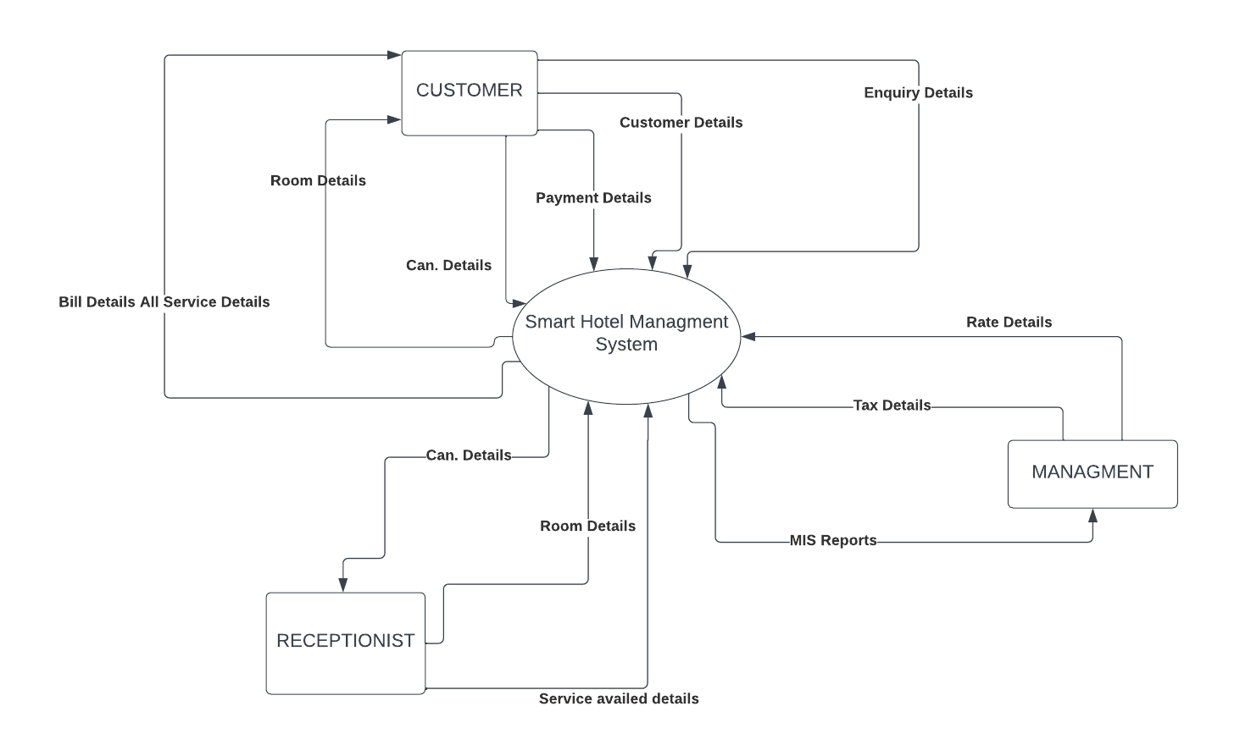

Fig 02: Data Flow Diagram

#### ER Diagram

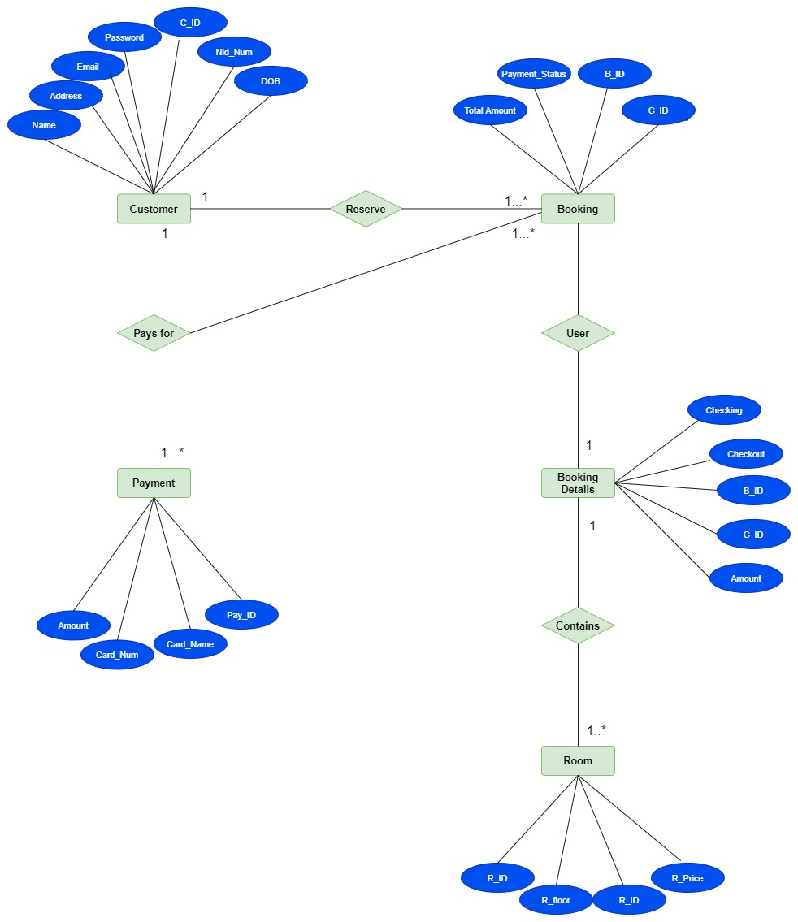

Fig 03: ER Diagram

Page **15** of

#### Activity Diagram

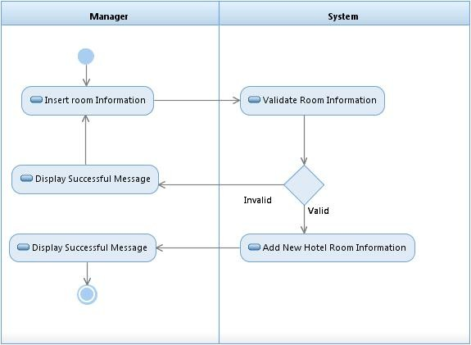

FIG 04: Add new Hotel Room by Manager

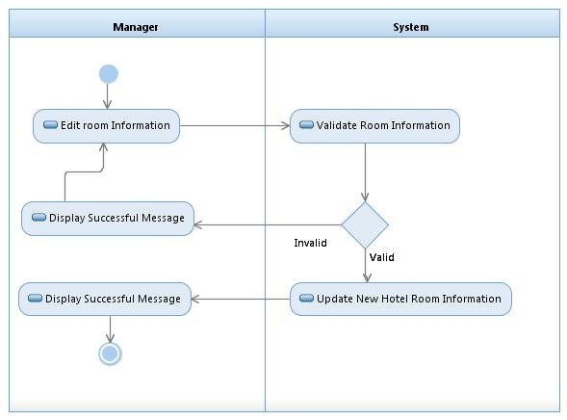

FIG 05: Edit Room by Manager

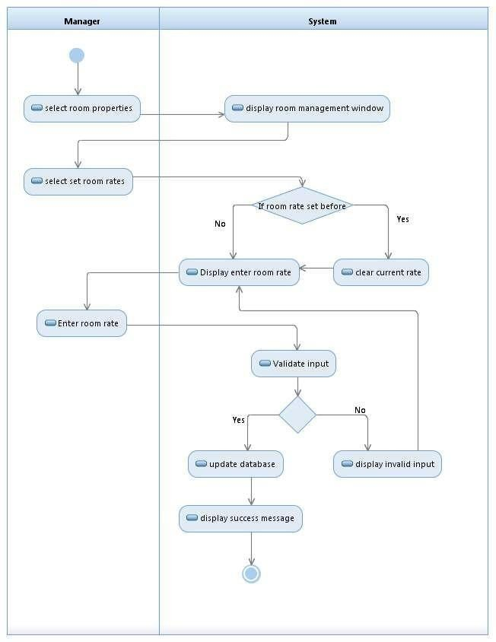

FIG 06: Set room rate by Manager

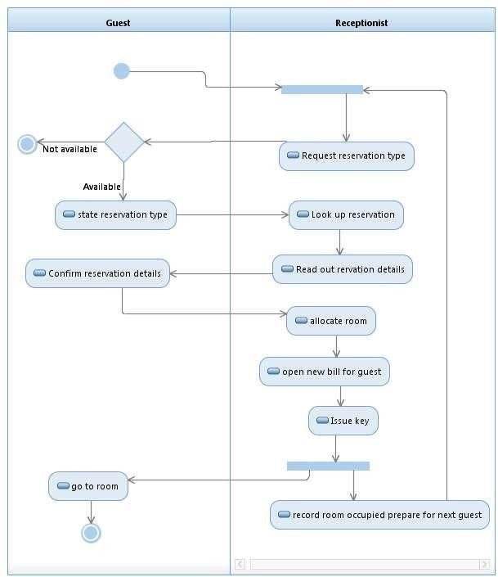

FIG 07: Make Room Reservation

### Data Dictionary

Sample of Customer Data dictionary:

|  |  |  |  |  |
| --- | --- | --- | --- | --- |
| Entity | Attribute | Type/Size | Validation | Key |
| Customer | C_ID | Number(5) | 10000-99999 | Primary |
| Customer | Name | Text(40) | Required |  |
| Customer | Email | Text(40) | Valid Mail |  |
| Customer | Phone | Text(13) | Required |  |
| Customer | Address | Text(50) | Required |  |
| Customer | DOB | Date(8) | Valid Date |  |
| Customer | NID_Num | Text(10) | Required |  |
| Customer | Password | Text(32) | Required |  |
| Customer | Confirm_passwor  d | Text(32) | Required |  |

Sample of Booking Data dictionary:

|  |  |  |  |  |
| --- | --- | --- | --- | --- |
| Entity | Attribute | Type/Size | Validation | Key |
| Booking | B_ID | Number(6) | 100000-999999 | Primary |
| Booking | C_ID | Number(5) | 10000-99999 | Foreign |
| Booking | Total_amount | Number(6) | (5000-100000) |  |
| Booking | Payment_Statu  s | Text(8) | Required |  |

Sample of Room dictionary:

|  |  |  |  |  |
| --- | --- | --- | --- | --- |
| Entity | Attribute | Type/Size | Validation | Key |
| Room | R_ID | Number(4) | (201-1640) | Primary |
| Room | R_type | Text(8) | Required |  |
| Room | R_price | Number(6) | (5000-100000) |  |
| Room | R-floor | Number(2) | Required |  |

### UI/UX Design Specification

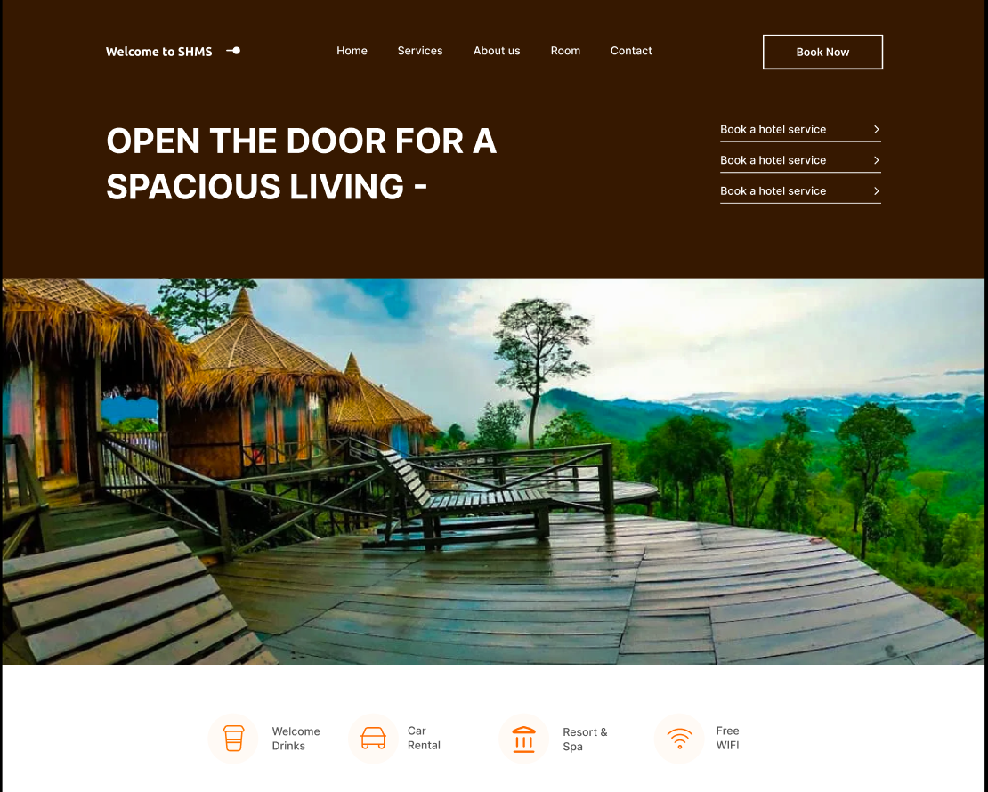

Fig 07: User friendly dashboard of system

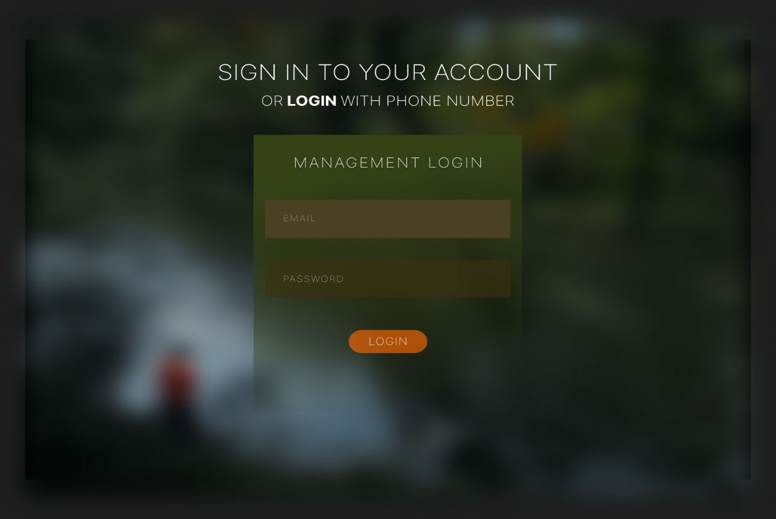

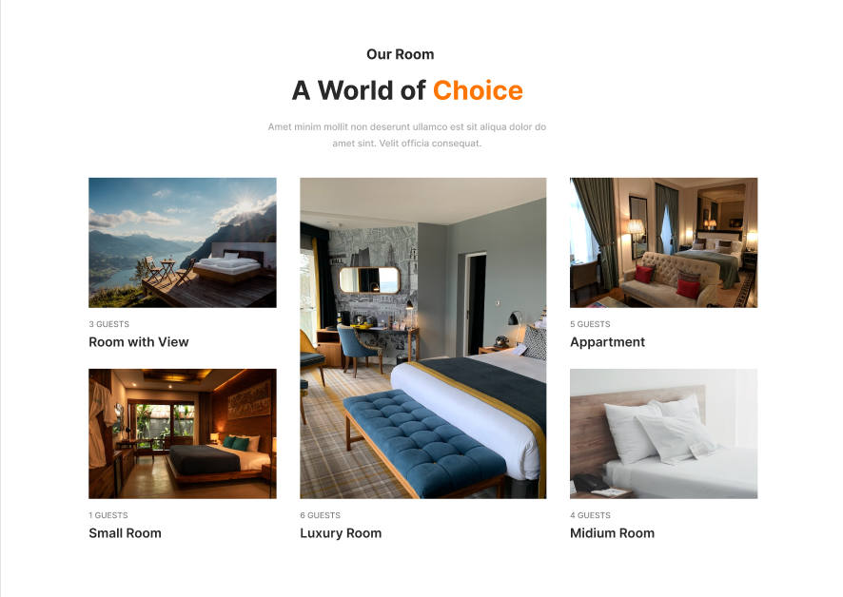Fig 08: Login interface is used to login to the system using username and password for Management users and can be used same interface for different users.

Fig 09: User Interface for Customer

# References

1. Gerald W. Latin, Modern hotel management, W.H.Freeman, 2011.
2. Michael J. O'Fallon, Denney G. Rutherford, Hotel Management and Operations illustrated edition, John Wiley & Sons, 2001
3. IanSommerville,*Software Engineering 8th edition*.Pearson education,2008.
4. ElmasriNavathe,*Fundamentals of Database System 3rd edition*.Pearson education,2000.
5. RaguRamakrishnan/JohnesGehrke,*Database Management Systems 3rdedition*.McGrow- HILL,2003.

#### World Wide Web:

1. ”Hotel Management Case Study”, March.6, 2010. [Online].Available[:http://www.scribd.com/doc/27927992/Hotel](http://www.scribd.com/doc/27927992/Hotel-Management-Case-Study)-[Management-Case-Study,](http://www.scribd.com/doc/27927992/Hotel-Management-Case-Study) [Accessed: June.28, 2014]
2. ”High-Level-SoftwareFeatures”,[Online].Available:http://www.high-level software.com/features/, [Accessed: June.25, 2014]
3. Fernandez & Yuan, X,(1999). An analysis Pattern for Reservation and Use of Reusable Entities.
4. PloP 1999 conference, Retrieved from <http://hillside.net/plop/plop99/proceedings/Fernandez2/reservanalysisPattern3.PDf>